Team 5 – Relevant Links the onboarding process

**Camunda Tasklist:** https://digibp.engine.martinlab.science/camunda/app/welcome/default/#!/login

**Login:** jasminwinter

**PW:** password

**Start the following process:** «OnboardingProcess 25DIGIBP31

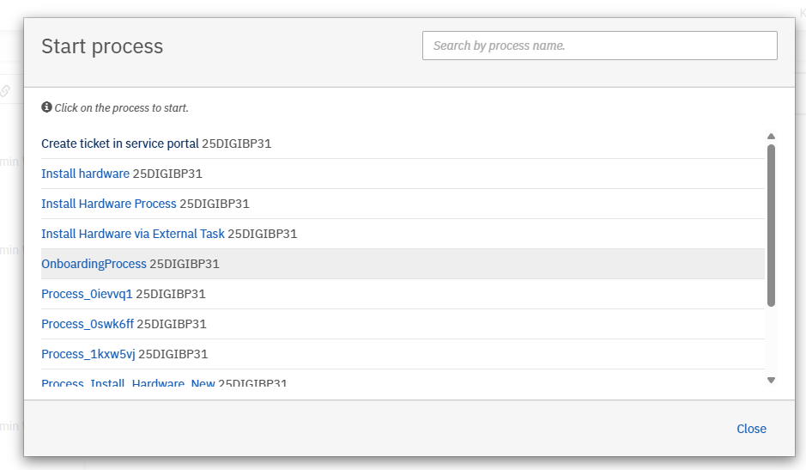

**Postman – Receive Signed Contract**

* **Method:** POST
* **URL:** https://<camunda-server>/engine-rest/message
* **Headers:** Content-Type: application/json
* **Body:**

{

"messageName": "SignedContractReceived",

"businessKey": "37c4ad70-3ffc-11f0-8dd5-fa163ee583d0"

}

Enter the business key of the current process

**Postman – Hardware received**

* **Method:** POST
* **URL:** https://<camunda-server>/engine-rest/message
* **Headers:** Content-Type: application/json
* **Body:**

{

"messageName": " HardwareReceived",

"businessKey": "37c4ad70-3ffc-11f0-8dd5-fa163ee583d0"

}

Enter the business key of the current process

**Make**

Andreas Martin, Charuta Pande and Devid Montecchiari were invited to our make szenarios.

Invitation from Jasmin Winter for the following szenarios:

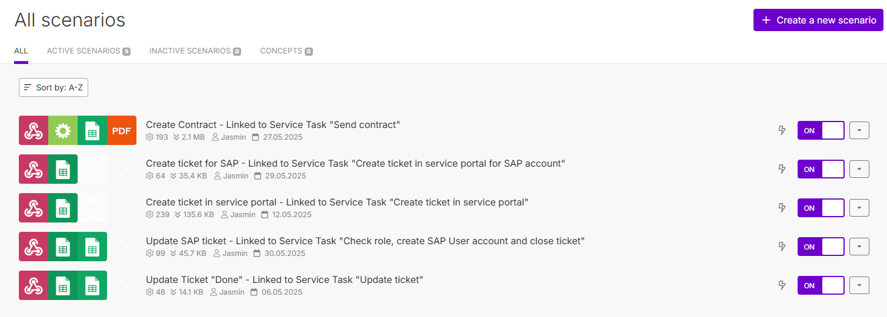

Invitation from Claudio Schwaiger for the following szenarios:

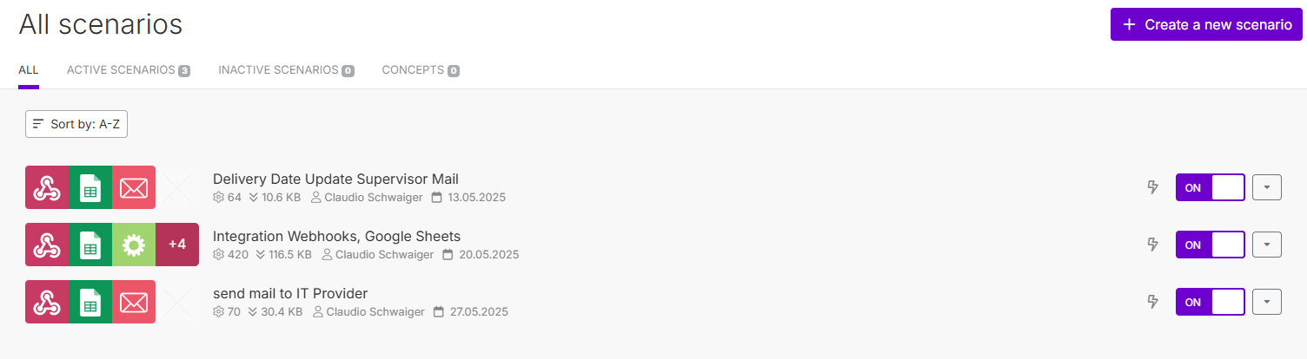

**Google Sheets - Ticketing System:**

<https://docs.google.com/spreadsheets/d/13k5fA20LIqMRKZEzLRBSk8IYvtqWcN5pYFdKsIwxZ_o/edit?usp=sharing>

**Google Sheets - My New Employee:**

<https://docs.google.com/spreadsheets/d/1hhiLwUhfL_jMdI90sm_WGVLJqdzsWvnNceuhtx8Jt3c/edit?usp=sharing>